Main Title of Long Paper: [Roboto 18 bold]
Subtitle of long paper [Roboto 16]

Double-blind review process

Do not include authors in the body text at this time

ABSTRACT: This abstract should be a maximum of 300 words in a single paragraph. Read these notes below carefully all the way through and follow them as precisely as possible. This document explains how to prepare a paper for submission to the Metagreen 2020 Conference. This MS-Word document should be used as a template. Text in red gives some overview on layout and must be deleted in your paper version. [Roboto 9 italic, justified, Single line spacing, Followed by one blank line]

KEYWORDS: Energy, Comfort [Up to 5, Roboto 9 italic, followed by 2 blank lines]

1. INTRODUCTION [HEADING-Roboto10pt bold capitals]
[Main Text: Roboto 10pt] Full papers will be double blind reviewed by the conference review committee and their decisions shall be final. All shortlisted full papers will be published in the conference proceedings. The Authors will receive a hardcopy containing the extended abstracts of the papers (2 page long) and the full paper will be published online on the Metagreen Dimensions website. Shortlisting of abstracts does not ensure final acceptance. The accepted full papers will be invited for oral presentation at the conference venue. This invitation shall be intimated to the respective author through the MG2020 website.
Authors should ensure that the papers submitted to MGD4.0 are original, and have not been published elsewhere. The copyright document should be uploaded along with full paper. For each accepted paper at least one of the authors must register for the conference.

2. STRUCTURING THE RESEARCH PAPER
The full papers should be limited to 3000 words and the maximum extended including reference and illustration should be limited to 8 A4 sheets. The format should be followed completely. Failure to comply with instructions may result in rejection. The margin in the format template should not be altered. One line spacing after each section and subsection should be provided. The text should be justified with one line spacing. Section and subsection heading format should be followed as recommended. In case of any doubts refer to the Publication manual of the American Psychological Association, 6th Edition, published in 2010.
2.1 Themes and title [Subheading: Roboto 10pt bold, upper and lower case]
The content of the full paper should be related to one of the conference themes. The themes are:
- Design for social innovation
- Sustainability, livability and resilience of Asian and African cities
- Performance of buildings
- Green platform: Pedagogy, process and policies
- Conservation and documentation of built heritage
The title should be clear and concise. Avoid use of abbreviations in title. The body of the paper should be preceded by a 300 word abstract briefly describing the paper and followed by keywords up to 5 in number.

2.2 Citation and references
Citation and references must follow the APA Citation style. Citations in APA usually include require author name, publication year, work title, publication city, and publisher in that order.
References must appear separately at the end of the paper, as a separate page, and not as footnotes. The page must have the title ““References” at the centre top of the page. Authors' names must be inverted, listing last name first. In case of multiple authors, provide the last name and initials followed by first name. The entries should be alphabetized by the last name of the first author of each work. For multiple articles by the same author, or authors listed in the same order, the entries must be given in chronological order, from earliest to most recent. Only the first word of the title of a work must be capitalized unless given otherwise in the title of the work itself.

Following the APA citation style, in-text citation must include the author’s last name, year of publication, and page number for the reference (preceded by "p."). For example, according to Sharma (2009), “APA is best suited for works in the social sciences.” (p. 67). It may also be stated in the following format: She argues that APA is best suited for works in the social sciences (Sharma, 2009, p. 67). While page numbers are not required, authors are highly encouraged to provide the same wherever possible. Direct quotations that are forty words or longer must be provided as a block quote. The quote must start on a new line indented at the same place as a new paragraph. The entire quote must be typed along this new margin. For details on the APA citation style, refer to the Publication manual of the American Psychological Association, 6th Edition, published in 2010.

2.3 Figures and tables
On the use of graphical representations and tables, first decide if the information is best given as a table or graphical representation, or as a text. Do not repeat information in both formats. If the paper has a table, the table number must be mentioned somewhere within the text. All tables must have a number (example: Table 1) and a title given above the table, such that Table number is followed by Title in a separate line. In case the table is from another source, the source must be given clearly at the end of the table in the APA reference style. The title must be brief yet self-explanatory. The font and font size must be same as the rest of the paper. Important words in the title must be capitalized, and the entire title must be italicized. Tables must place as close to their mention the text as possible. All columns in the table must have a column heading. The table must be horizontal. This means that vertical lines/rules separating the columns must be eliminated. See the example given below.

Table 1: Sky conditions probability for clear sky (ρ_{cs}), partly overcast sky (ρ_{ps}), and fully overcast sky (ρ_{os}).

Month | ρ_{cs} (%) | ρ_{ps}(%) | ρ_{os}(%)
JAN | 5.88 | 36.88 | 57.24
FEB | 6.79 | 45.65 | 47.57
MAR | 5.48 | 40.40 | 54.12
APR | 16.39 | 51.58 | 32.03
MAY | 11.18 | 45.27 | 43.55
JUN | 12.87 | 33.68 | 53.45

In case of graphical representations, all such figures must have a caption given below the figure. The caption must clearly explain the content of the figure. It must also indicate the source in the APA format. Note the example below.

Figure 1:
Clear line drawings are essential. [Roboto 9 italic, APA format]

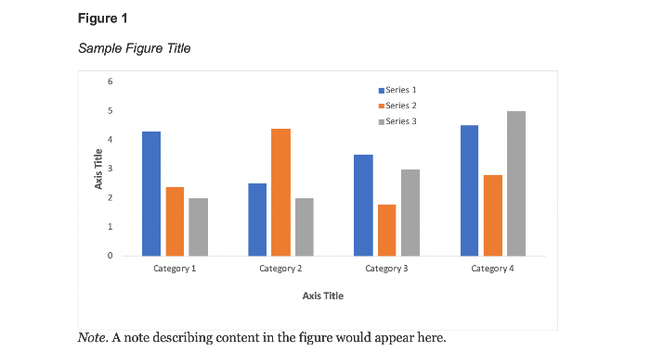
Note: Please refer https://apastyle.apa.org/style-grammar-guidelines/tables-figures/figures for more details on formatting tables and figures

2.4 Equations
Equations should be centered. They are numbered as (1), (2), etc. They are referred in the main texts as “Equation (n)”. Descriptions of the equation can start from the next line. For example, like the following Equation (1):
PET = 1.2Ta - 2.2v + 0.55 (Tmrt – Ta) (1)
where PET - Physiological Equivalent Temperature (◦C);
Ta - air temperature (◦C);
Tmrt - mean radiant temperature (◦C);
v - air speed (m/s).

3. SUBMISSION GUIDELINES
The document file uploaded should be named as MGD4.0_fullname of the author.doc. Log in to http://cat-tvm.in and go to login page. Login using your username (mail ID) and password. Complete the payment (refer to the submission section for payment details) and upload the full paper and the copyright document as .doc file. The last date of full paper submission is 27th October 2024.
We would appreciate it if you can do the above on or before 27th October 2024 (23:59 GMT) or at your earliest convenience before the time. Thank you very much.

4. CONCLUSION
The document was prepared as a template for the upcoming MGD4.0 conference. Hope to meet you during Metagreen dimension!

REFERENCES
Cascone, S. (2019). Green roof design: State of the art on technology and materials. Sustainability (Switzerland), 11(11). https://doi.org/10.3390/su11113020
Jamei, E., Ossen, D. R., Seyedmahmoudian, M., Sandanayake, M., Stojcevski, A., & Horan, B. (2020). Urban design parameters for heat mitigation in tropics. Renewable and Sustainable Energy Reviews, 134(August 2019), 110362.https://doi.org/10.1016/j.rser.2020.110362
Max-Neef, M. A. (2005). Foundations of transdisciplinarity. In Ecological Economics (Vol. 53, Issue 1, pp. 5–16). Elsevier. https://doi.org/10.1016/j.ecolecon.2005.01.014
Perraudeau, M., (1988). Luminance models. In National Lighting Conference. Cambridge, UK, March 27-30.

International Daylight Monitoring Programme, [Online], Available: http://idmp.entpe.fr/ [16 June 2008].

