Main Title of Short Paper: [Roboto 18 bold]
Subtitle of short paper [Roboto 16]
Your Name¹, Co-Author² [Roboto 10 capitals, followed by 1 blank line]

1Institution, City
2 Institution, City [Roboto 9, followed by 1 blank line)

ABSTRACT: This abstract should be a maximum of 300 words in a single paragraph. This document explains how to prepare a paper for submission to Metagreen Dimensions, Second International Conference on Performance of Built Environment. It includes the instruction for submission and some other information. This MS-Word document should be used as a template. Text in red gives some overview on layout and should absolutely be deleted in your paper version. [Roboto 9 italic, justified, Followed by one blank line]

KEYWORDS: Built Environment, Performance [Up to 5, Roboto 9 italic, followed by 2 blank lines]

INTRODUCTION [HEADING-Roboto 12 pt bold capitals]
[Main Text: Roboto 10 pt]. These instructions apply for the 2-page extended abstract. Novelty and background of the research should be explained in the introduction section. The extended abstract should be submitted by 30/12/2024. Please note that no guarantees can be given for oral/poster presentation of a paper until the receipt of the full version of the extended abstract and its final approval by the Scientific Committee. All approved extended abstracts will be published as hardcopy and handed over to the authors at the time of the conference. The full papers will be published as online proceedings and will be accessible to the authors from the conference website cat-tvm.in
Authors are fully responsible for their papers, which should not have been published elsewhere. They must have taken the necessary steps to obtain permission for using any material that might be protected by copyright.

- PREPARING THE MANUSCRIPT
With A4 paper size (210 × 297 mm), illustrations and references included, the extended abstract should be limited to 2 pages. A brief overview of the methodology used, data collected, tools/software used etc should be stated. The format should be followed completely. Failure to comply with instructions may result in rejection. The margin in the format template should not be altered. One-line spacing after each section and subsection should be provided. The text should be justified with one-line spacing. Section and subsection heading format should be followed as recommended.

2.1 Citation and References
Citation and references must follow the APA Citation style. Citations in APA usually include author name, publication year, work title, publication city, and publisher in that order.
References must appear separately at the end of the paper, as a separate page, and not as footnotes. The page must have the title “References” at the centre top of the page. Authors' names must be inverted, listing last name first. (Kramer, 2010) In case of multiple authors, provide the last name and initials followed by first name. The entries should be alphabetized by the last name of the first author of each work. For multiple articles by the same author, or authors listed in the same order, the entries must be given in chronological order, from earliest to most recent. Please refer to the full paper template already shared for more details.

2.2 Figures and Tables
While using graphical representations and tables, first decide if the information is best given as a table or graphical representation, or as a text. Do not repeat information in both formats. If the paper has a table, the table number must be mentioned somewhere within the text. All tables must have a number (example: Table 1) and a title given above the table, such that Table number is followed by Title in a separate line. For more details, refer to the full paper template.

Table 1: August average temperatures and departures from normal (˚F) for select cities. [Roboto 9 italic]
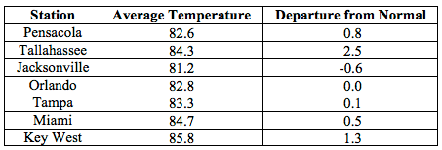
(Climate Summary for Florida. 2015 retrieved from climatecenter.fsu.edu/products services/ summaries/ climate-summary-for-florida-august-2015)

In case of graphical representations, all such figures must have a caption given below the figure. The caption must clearly explain the content of the figure. It must also indicate the source in the APA format. Note the example below.

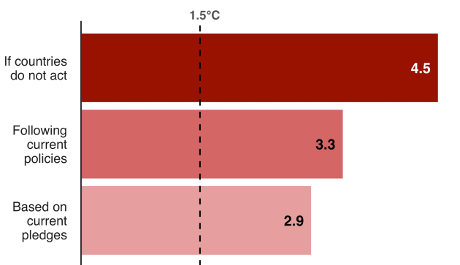
Figure 1: Climate Change Tracker. [Roboto 9 italic]
(Climate change, Science & Environment. 2019 retrieved from www.bbc.com/news/science-environment-46384067.)

2.3 Equations
Equations should be centered. They must be numbered as (1), (2), etc. Please refer to the full paper template for more details.

- CONCLUSION
This paper showed how to prepare and upload an extended abstract for inclusion in the MGD4.0 conference. We look forward to meeting you during the conference.

- SUBMISSION GUIDELINES
The document file uploaded should be named as MGD4.0. full name of the author.doc. Log in to http://cat-tvm.in and go to login page. Login using your username (mail ID) and password. Upload the extended abstract. The deadline for paper upload should be strictly followed. The deadline for submitting the full paper is December 30th 2024, 23:59 GMT.
Please refer to authentic reference materials for APA style referencing. In case of any queries please reach us at Metagreen@collarc.com.
Thank you for your cooperation. Looking forward to meet you during MGD4.0.

- REFERENCES
Cannan, J. (2008). Using practice based learning at a dual-sector tertiary institution: A discussion of current practice. In R. K. Coll, & K. Hoskyn (Eds.), Working together: Putting the cooperative into cooperative education. Conference proceedings of the New Zealand Association for Cooperative Education, New Plymouth, New Zealand. Retrieved from http://www.nzace.ac.nz/conferences/papers/Proceedings_2008.pdfhttp://www.nzace.ac.nz/conferences/papers/Proceedings_2008.pdf
Greenhaus, J. H., & Parasuraman, S. (1999). Research on work, family, and gender: Current status and future directions. New York: Sage Publications.
Palmer, F. (2007). Treaty principles and Maori sport: Contemporary issues. In C. Collins & S. Jackson (Eds.), Sport in Aotearoa/New Zealand society (2nd ed., pp. 307-334). South Melbourne, Australia: Thomson.
Plea A Coruna Planning Post Carbon Cities. 2020 retrieved from www.plea2020.org/templates
Western Regional Climate Center. (2013) Cooperative Climatological Data Summaries. Retrieved from http://wrcc.dri.edu/climatedata/climsum/

[Roboto 9, Alphabetic order]

